**Chapter 8: The Giant Planets**

**8.1: Giant Planets are Large, Cold, and Massive**

**Characteristics of the Giant Planets**

* We can calculate the relative size of the giant planets using *stellar occultation*
  + This is when a planet passes in front of a star, and the time it takes to pass in front
* Giant planets contain 99.5% of solar system’s mass (not including sun)
  + Jupiter = more than 2x more massive than all other things in solar system combined
* We calculate the mass of giants using satellite deflection
  + We measure the deflection of a passing satellite caused by the planets gravity

**Composition of the Giant Planets**

* Jupiter/Saturn = gas giants. Composed mainly of hydrogen and helium
  + Atmosphere is thousands of kilometers thick
  + Ocean underneath
* Uranus/Neptune = ice giants. Composed of water & other ice.
* These planets are not dense at all (Saturn is less dense than water)
* Contain mainly hydrogen and helium (based of the solar abundance reference to composition)
  + Also has methane, ammonia, hydrogen sulfide, and water
  + Uranus/Neptune contain more heavy elements than the other two

**Rotation of the Giant Planets**

* Giants rotate extremely fast, causing some of them to become oblate (not spherical)
  + Saturn’s diameter is 10% larger around the equator than anywhere else
  + 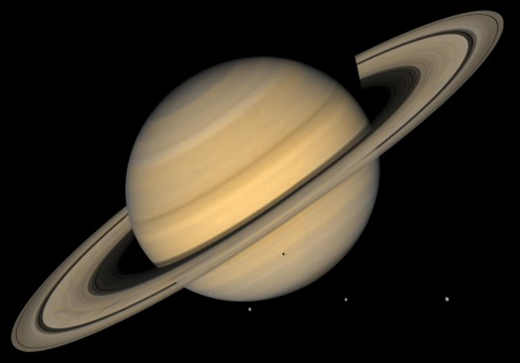
* Seasons on giants based on axial tilt
  + Jupiter has almost no seasons (axial tilt of 3 degrees)
  + Saturn/Neptune are more similar to Earth
  + Uranus has extreme seasons (tilt of 98 degrees)
    - Uranus, Venus, Pluto, Charon, and Triton only things in solar system like this

**8.2: The Giant Planets Have Clouds and Water**

**Viewing the Cloud Tops**

* Jupiter most colorful
  + Darker zones called belts, lighter ones called zones
  + Great Red Spot (could fit 2 Earths)
  + 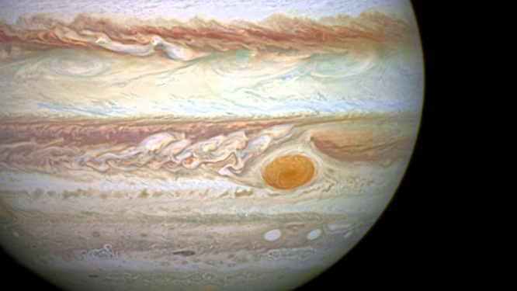
* Rotates like a hurricane, in opposite direction (anticyclonic – indicates high pressure zone)
  + These hurricane areas can be seen on other planets (called vortices)
* Saturn appears twice as small as Jupiter from Earth
  + Has clouds that appear sometime
  + Southern hemisphere known as “storm alley” (lightning seen here)
* Neptune has a great dark spot, similar to the great red spot
  + Methane in atmosphere absorbs light from sun, making it look darker

**The Structure below the Cloud Tops**

* 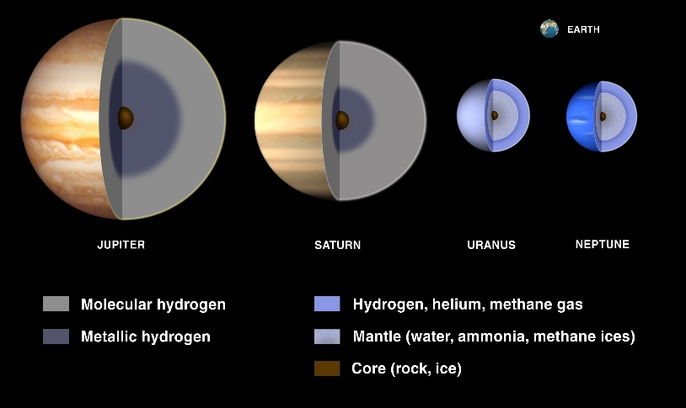
* 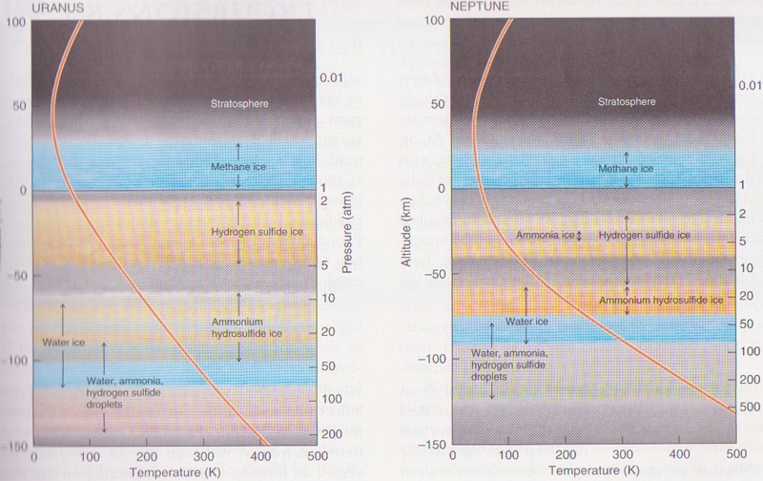

**Convection and Weather**

* Giant planets have strong zonal winds, and rotate very fast, so the Coriolis effect is strong
  + Convection is not caused by Sun here, but by the planet’s cores
  + This convection happens fast, causing strong lightning, as seen on Jupiter (equivalent to Earth’s superbolts)

**Winds on Jupiter and Saturn**

* Winds on planets change depending on latitude
  + Jupiter’s strongest wind at equator (550 km/h)
    - These are westerly winds
  + Saturn also has westerly strong winds, but much stronger than Jupiter (1,650 km/h)
    - Saturn’s Jetstream is similar to Earth’s. Found at 45 degree N, blows in a sinusoidal pattern

**Winds on Uranus and Neptune**

* Not much is known about winds on Uranus
  + Winds similar to other giant planets, something not thought due to its peculiar orientation
* Neptune is also similar to other planets, except that the strongest winds here are easterly and not westerly (over 2,000 km/h)

**8.3: The Interior of the Giant Planets are Hot and Dense**

**Cores**

* Center pf giants are dense liquids of water, rock, and metals. Extremely hot cores (35,000 K)
  + Cores drive convection, eventually dissipating heat into space.
  + Planets stay hot due to continual shrinking (gravitational converted to thermal energy)
* Farther down you go in atmosphere, higher the pressure is, which eventually “creates” the oceans of the giants

**8.4: The Giant Planets are Magnetic Powerhouses**

**The Size and Shape of the Magnetosphere**

* Orientation of magnetospheres of gas giants varies greatly from one to another
* These spheres are massive, often times larger than the sun itself
* They are also effected by solar wind
  + It can twist, push, and pull the magnetospheres of the giants
* 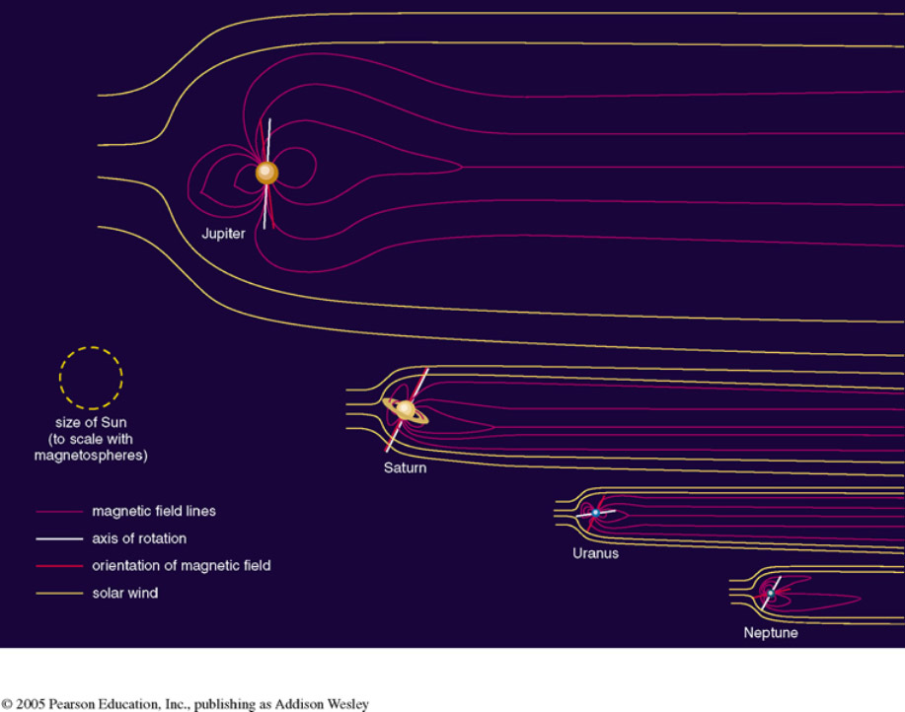

**Charged Particles and Auroras of the Giant Planets**

* Jupiter slings around magnetically charged particles so fast that they collide and heat up to roughly 300 million K.
  + These particles are confined to the radiation belts of the planets, which can produce up to 400,000 rads
  + Releases radiation in the radio spectrum, called *synchrotron radiation*
* We can find the exact rotational period of a planet by looking at its magnetosphere’s rotational period
* Most intense radiation belt = *Torus* (found around Io)
  + 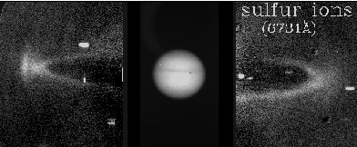

**8.5: Rings Surround the Giant Planets**

**Orbits of Ring Particles**

* Ring particles rotate circularly in a single plane due to collisions between particles
* Moons of planets also effect the rings, causing gaps in the rings (Saturn’s Cassini Division caused by the moon Mimas)
* Nearby moons of planets are known as shepherd moons due to their “herding” nature

**Ring Formation and Evolution**

* Roche limit = the distance at which the tidal stresses on a moon orbiting a planet exactly equal the self-gravity of that moon
  + If a moon/planet reaches this limit, it is torn apart by tidal stress
  + Once torn apart, the particles left over orbit the closest large body, forming rings
* Most all rings will eventually dissipate and fly off into space
  + Saturn’s E ring will not as long as Enceladus is geologically active (it supplies continual ice to the ring)
* Earth probably had a ring at some point, but lacks shepherd moons to keep it

**Composition of Rings**

* Composition of planetary rings is very similar to the composition of the planet’s moons
* Saturn’s rings are composed mainly of water ice and some other silicate
  + Brightest rings in the solar system
* Jupiter’s brightest ring is relatively small, similar in composition to its moons Metis and Andrastea
  + Gossamer rings of Jupiter are very tenuous, provided for by Amalthea and Thebe
  + Inner ring, the halo ring

**Structure of Ring Systems**

* 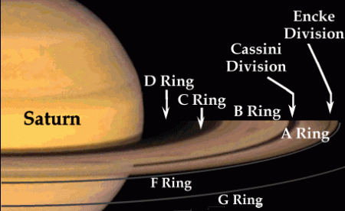
  + Ringlets = narrowly confined concentration of ring particles bounded on both sides by regions of relatively little material
  + Diffuse ring = particles are far apart, and rare collisions between them can cause their individual orbits to become eccentric, inclined, or both
  + Ring arcs = high-density segments of the narrow ring